Lesson 9 Demo 3
Continuous Monitoring on Docker with ELK Stack

Objective: To demonstrate continuous monitoring on Docker with ELK stack.

Tools required: Jenkins, Docker, ELK stack.

Pre-requisites: You need to have Docker, Jenkins installed along with a set of the required plugins (Docker, Docker pipeline, build pipeline etc). In case you don’t have Jenkins installed refer to the Unassisted practice of lesson 5 or refer to the lab guide. For Docker installation refer to demo 1 of lesson 8 or refer to the lab guide.
Also you need to have a Docker hub account in order to proceed with this demo. In case you don’t have one, you can create it by navigating to https://hub.docker.com/
Steps to be followed:
- Set up ELK stack on Docker
- Configure Jenkins pipeline for Docker build and deployment
- Run the Spring Boot application and check the logs in Kibana

Step 1: Set up ELK stack on Docker
Note: We will create a Docker Compose YAML file that will run all three components of ELK stack on Docker environment. Once that is done, we can access Kibana Dashboard to see the logs pushed to application.

- Download Docker compose file in one of the git repositories and follow the set of commands given below to initialize the ELK stack.

sudo su
git clone https://github.com/Siraj-ul-muneera/ELKExample.git
cd ELKExample
ls -alrt
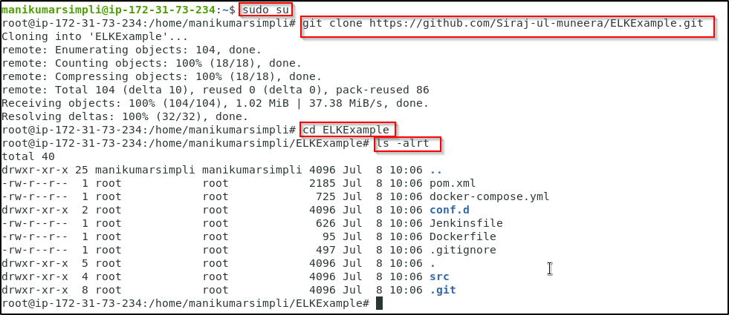
- Start the ELK stack using the docker-compose command. Usually, this binary is not installed on a server. So, follow the set of commands given below to install Docker Compose.

apt install docker-compose
docker-compose version
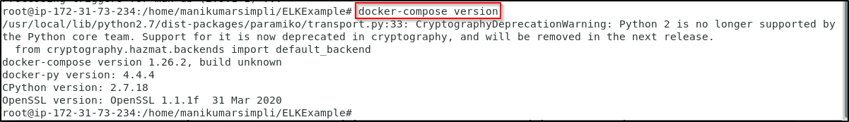
- Before starting the ELK stack, run the command given below so that elastic search is configured properly.

sysctl -w vm.max_map_count=262144

- Run the docker-compose command to initialize the ELK stack.

docker-compose up -d
docker ps
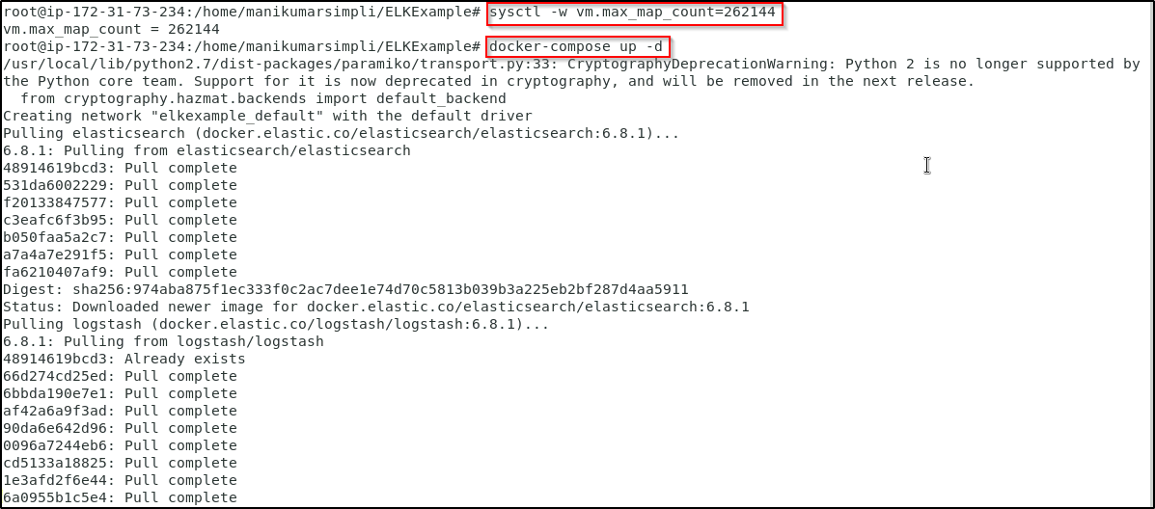
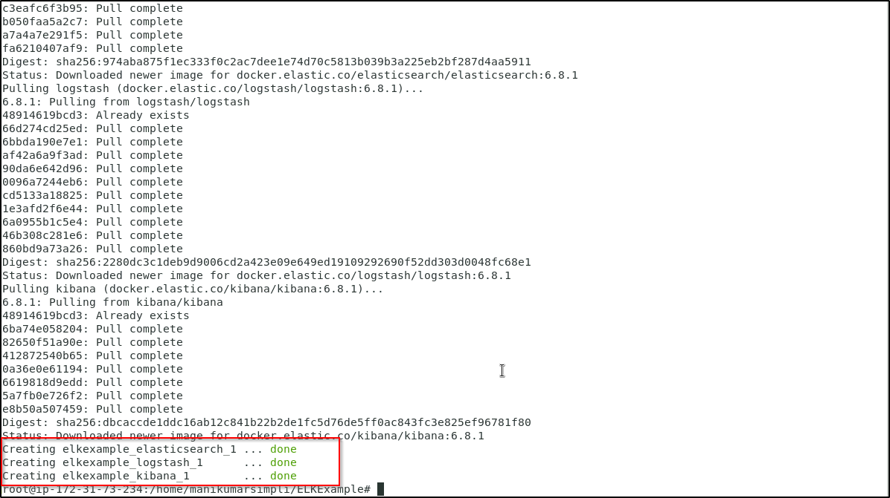

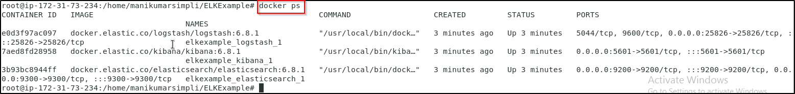
- Open the Kibana URL using the public IP of the host and 5601 port to access the Kibana dashboard.

http://localhost:5601/app/kibana

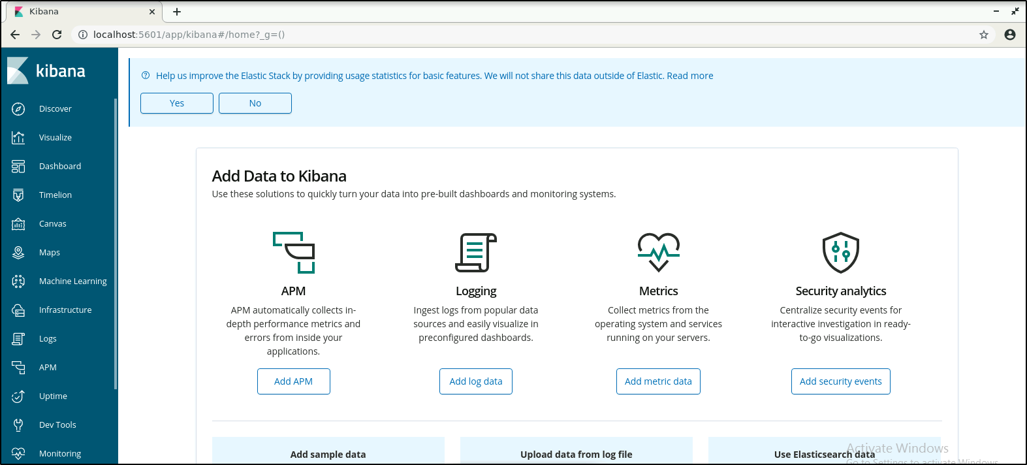

Step 2: Configure Jenkins pipeline for Docker build and deployment
- From the browser, navigate to http://localhost:8080 and login to Jenkins.
- Configure your Docker hub credentials in Jenkins. Go to Manage Jenkins -> Manage Credentials -> click on Jenkins link -> click on Global credentials (unrestricted) -> click on Add Credentials from the left pane.
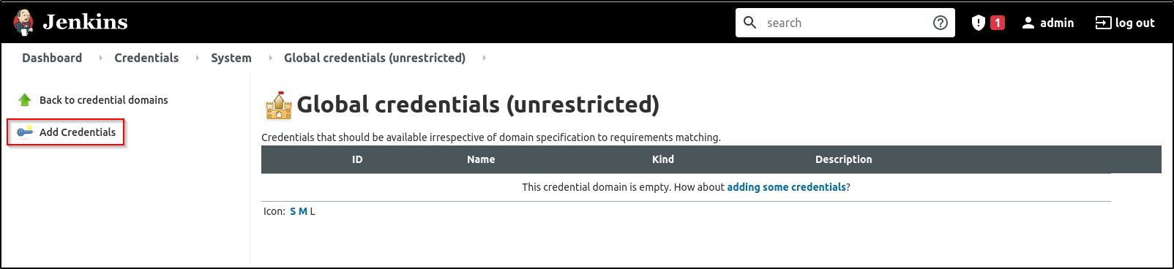
- Add the details as shown below
Username: <Your_DockerHub_Username>
Password: <Your_DockerHub_Password>
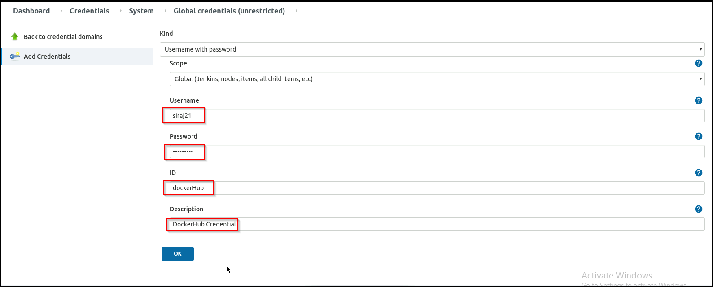
- You should now see the credentials saved as shown below
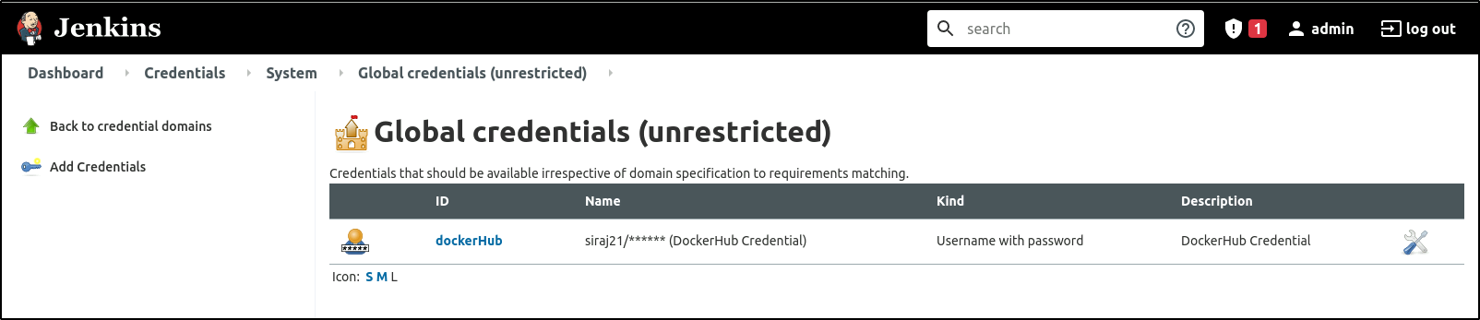
- Create a Jenkins pipeline job to fetch Jenkinsfile from the URL mentioned below. 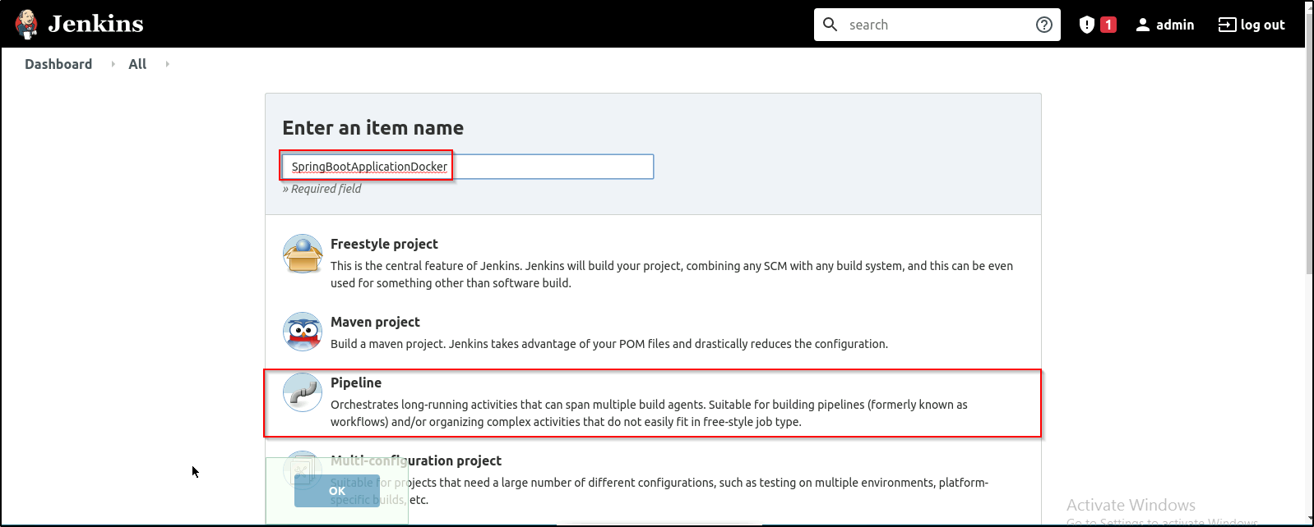
- You can either use the below git repository or Fork it in your Github account and use it
https://github.com/Siraj-ul-muneera/ELKExample.git

- Configure the job as shown in the screenshot below and then run the build.

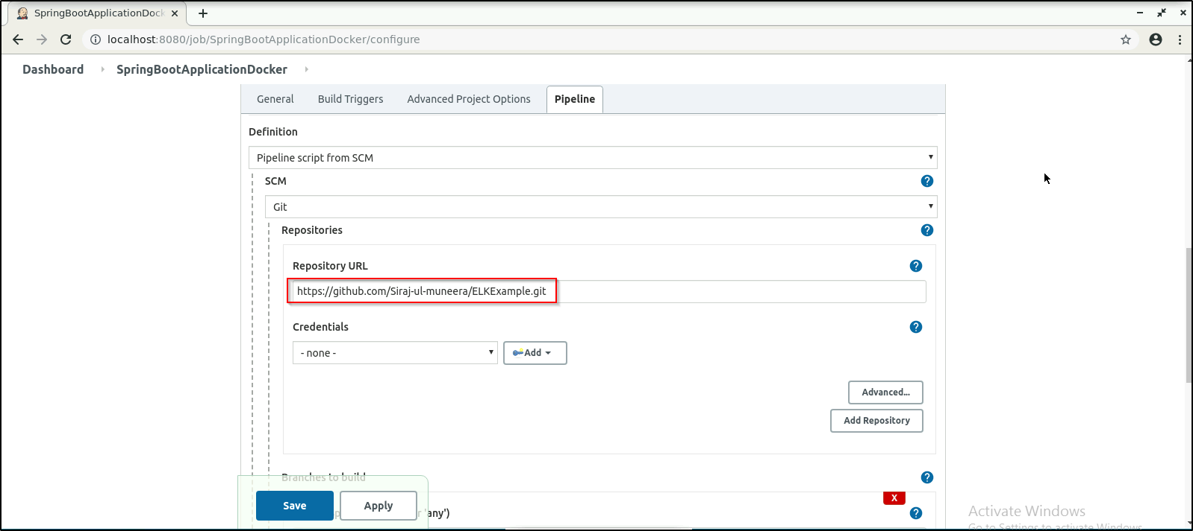
- Give 777 permission to the Docker sock file since we are running Docker command from a Jenkins user.

chmod 777 /var/run/docker.sock

- Build the Jenkins job to deploy the Docker container on the Docker host.

- Jenkins pipeline will complete the build and the deployment process for the Spring Boot application
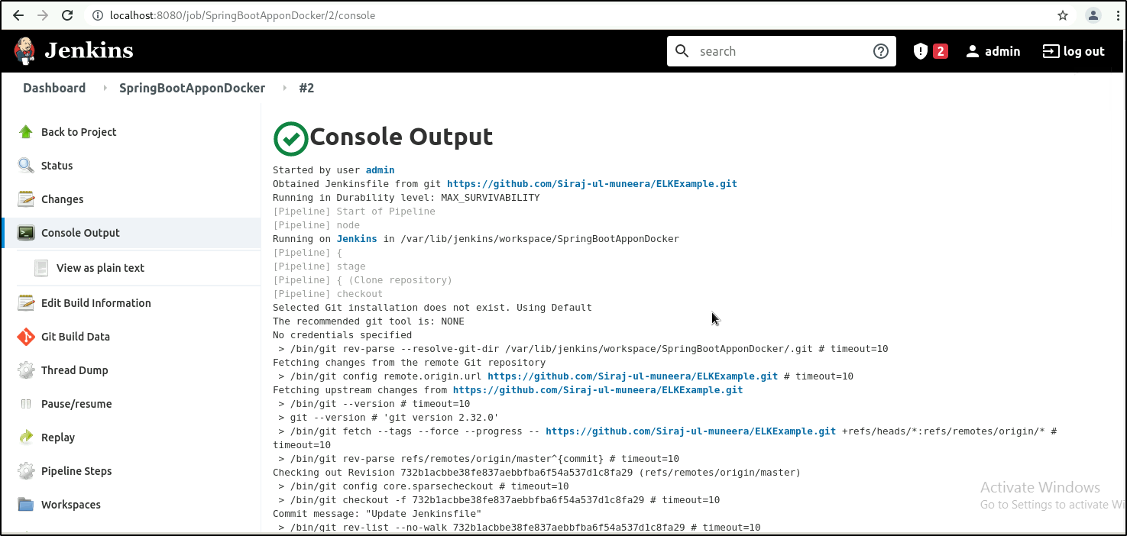
Note: If Console output is Failure follow the below mentioned steps.
Login to your GitHub account.
Fork the repository
https://github.com/Siraj-ul-muneera/ELKExample.git
Open Jenkinsfile and replace dockerhubaccountid with your DockerHub Username.
Save and copy the URL.
Paste the URL while creating Jenkins Pipeline Job.

We can see the Docker container deployed on the Docker host using the command:

docker ps | grep springbootapp

Step 3: Run the Spring Boot application and check the logs in Kibana

- Access the Spring Boot web application and perform some random activity so that the logs will be pushed to ELK stack.
http://localhost:81
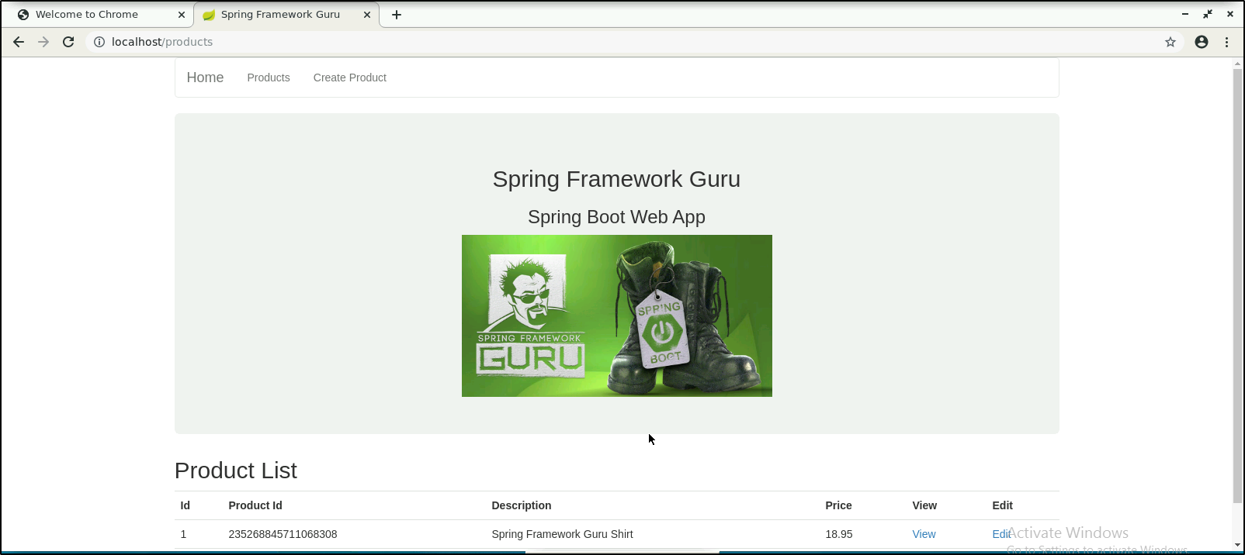
- Check the logs pushed to ELK stack in Kibana.

- Navigate to the Kibana dashboard. Select Management > Index Management from the navigation bar on the left. You can see the logs created.

